***Early interventions*** ***minimize the*** ***emotional effects of*** ***a traumatic event***

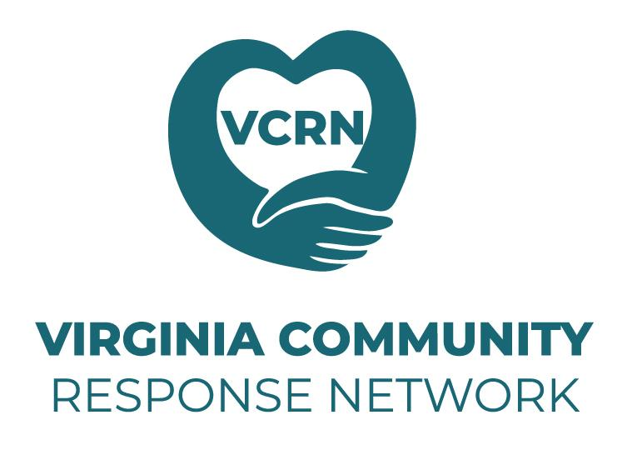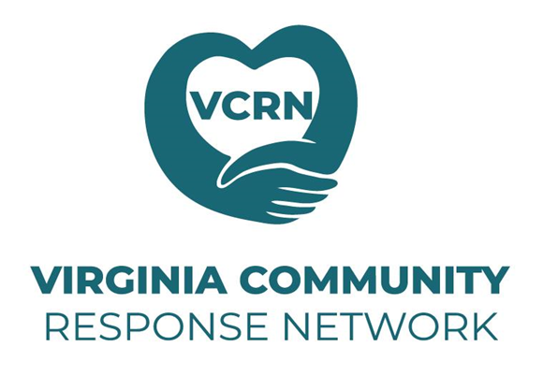*VCRN volunteers provide free & immediate stress relief service post-disaster to individuals or group, both in-person or virtually.*

**Who we are**

VCRN is a team of over 50 specially trained EMDR clinicians. We volunteer to respond to traumatic events that occur in Virginia and have the capacity to overwhelm a community. Traumatic events may include natural or environmental disasters, community violence, work-related accidents, etc. We serve affected community members, first responders, and emergency personnel. VCRN is a 501(c)(3) organization. Services are free of charge.

**What to expect**

Our licensed mental health clinicians are trained in trauma-focused treatment protocols including both early Intervention (EI) & EMDR Early Intervention (EEI). These provide immediate relief of the extreme feelings of stress; improve one's view of themselves, & offer relief from bodily disturbances that occur following experiencing a traumatic event. The goal is to return the person to pre-event mental health by targeting the triggers that cause intrusive memories of the event, which decreases the risk of developing PTSD.

**Signs of distress**

After a disaster, survivors, their loved ones, or first responders may experience distress such as: changes in sleep, appetite, or energy level; feeling unable to perform daily tasks; feeling confused, forgetful, irritable, angry, worried, hopeless, or scared; experience an increase in substance use, flashbacks, nightmares, or suicidal thoughts; or cannot stop thinking about the incident.

**Deployments**

We receive referrals from schools, churches, local and state government, mental health and health care professionals, first responders, and other community organizations. The decision to deploy clinicians to events is based on the number of people impacted, injuries or casualties, disruption of normal life activities, and if the events overwhelm the normal coping behaviors of people involved.

**Contact us**

Website[www.vcrn.org](http://www.vcrn.org) Telephone (434)202-6322

Email [contact@vcrn.org](mailto:contact@vcrn.org) Facebook and Instagram @VirginiaCRN